**CivicData Load Balancing**

Notes:

1. Get azure’s login account from superior. (https://portal.azure.com)
2. Be careful operation.
3. CKAN VM instances list (not contains adminportal and dataloader)

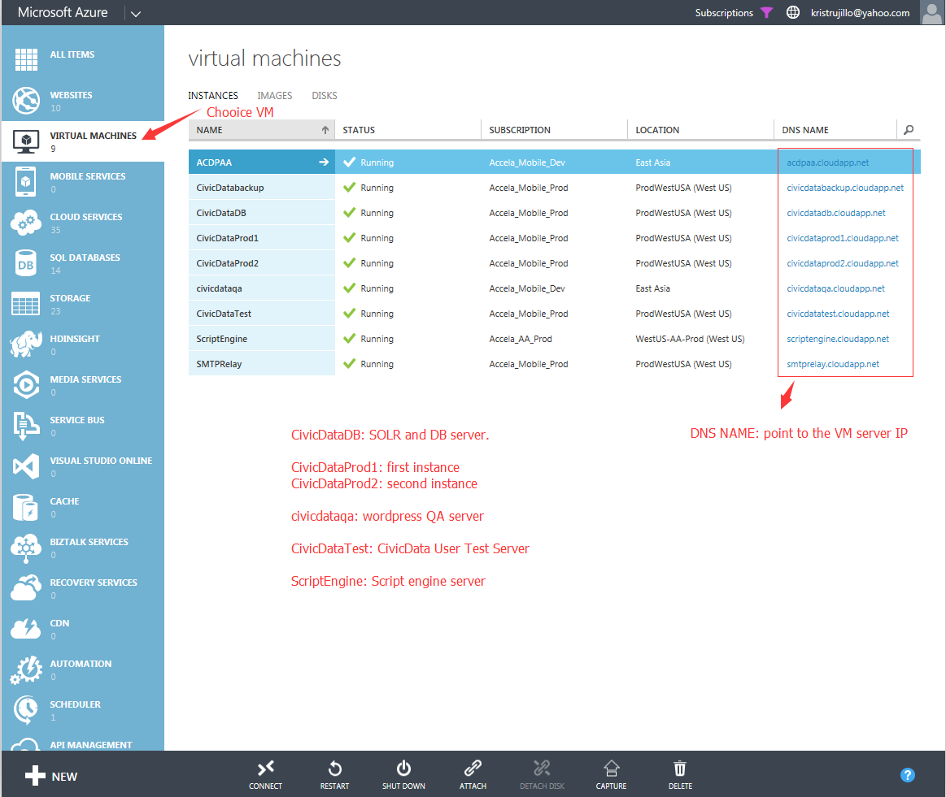

1. Traffic manager, Microsoft Azure provide a DNS load balancing solution.

The domain: civicdataprod.trafficmanager.net.

Civicdata.com by A record parsing to “civicdataprod.trafficmanager.net”.

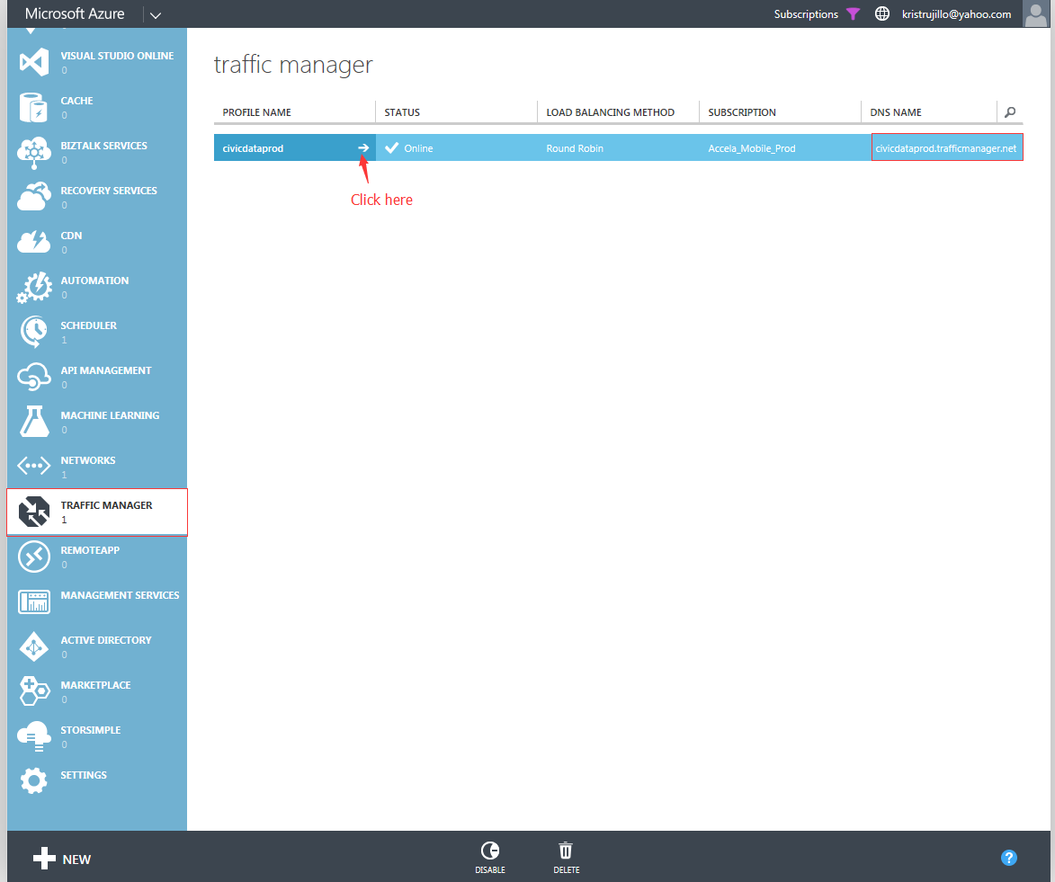

1. ENDPOINTS config.

In here, you can manage and configure more VM server if you need. But now we can’t do this, because the CKAN architecture bottlenecks.

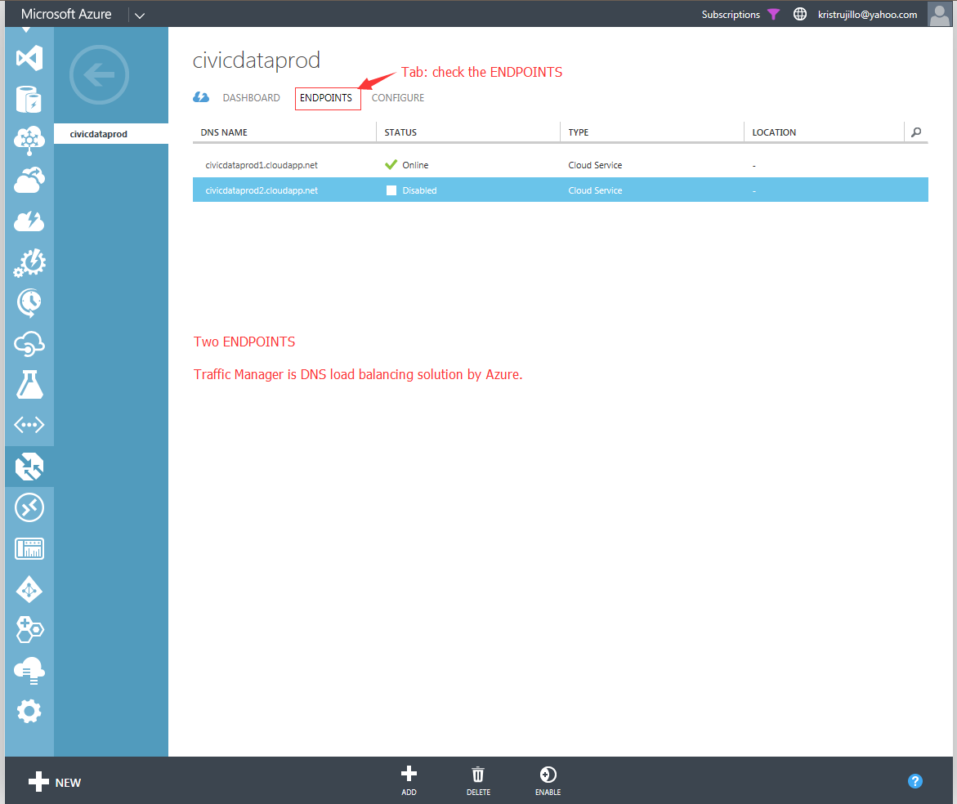

This is CivicData’s Load balancing implement.

Any questions please email to me.

Thanks.